**PROBLEM STATEMENTS**

**DASHBOARD 1**

Year of ‘Order purchased time’: 2016, 2017, 2018

I.1 – SQL

Total Order Quantity of 2017 & 2018? YOY Order Quantity change?

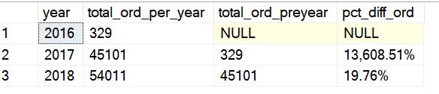

I.2-SQL

Total Revenue of 2017 & 2018? YOY Revenue change?

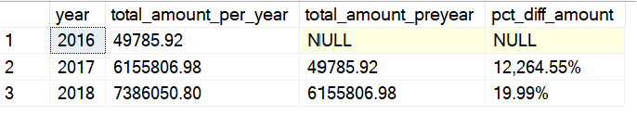

I.3-SQL

Show Total Order Quantity of 2017 & 2018 on Sparkline by month

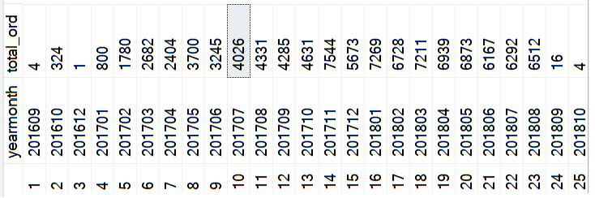

I.4-SQL

Show Total Revenue of 2017 & 2018 on Sparkline by month

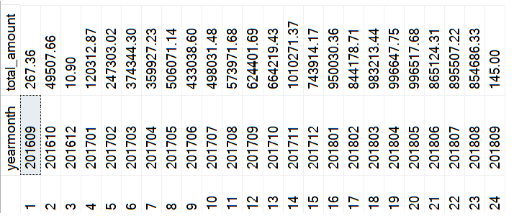

I.5 & I.6 - SQL

Total Revenue/ Order Quantity of 2017 & 2018 by Order Status

Axis: Order Status

Metrics: Total 2017 Order Qty, Total 2017 Revenue, Total 2018 Order Qty, Total 2018 Revenue

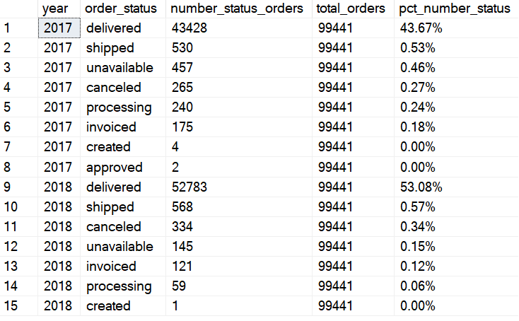

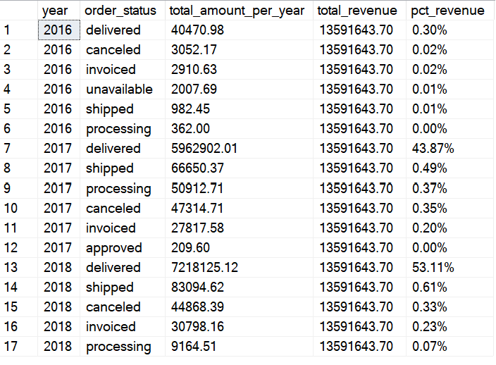

I.7 & I.8

Total delivered Revenue/ Order Quantity of 2017 & 2018 by Day of Week (Bar Chart)

Axis: Order Status

Metrics: Total Delivered 2017 Order Qty, Total Delivered 2017 Revenue, Total Delivered 2018 Order Qty, Total Delivered 2018 Revenue

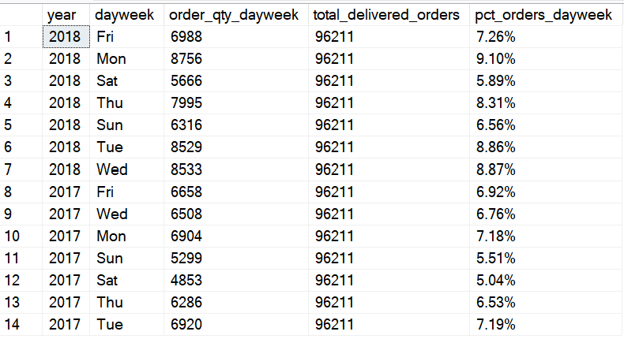

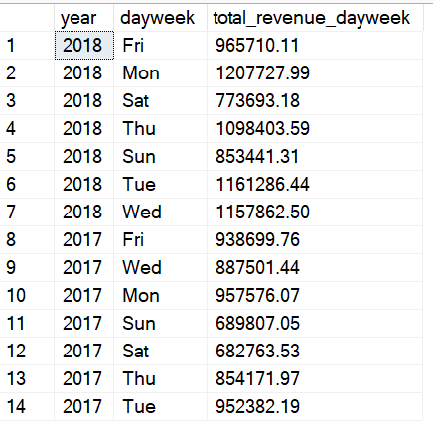

I.9 - SQL

Total Revenue/ Order Quantity of 2017 & 2018 by Time of Day

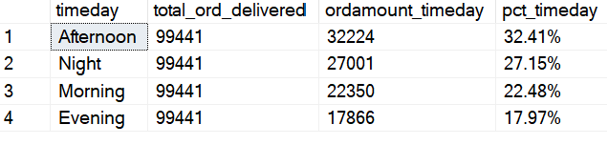

**DASHBOARD 2**

III.1 & III.2 - SQL

Total Revenue/ Order Quantity of 2018 by State (Bar Chart)

*Notes: Each order has a unique customer_id.*

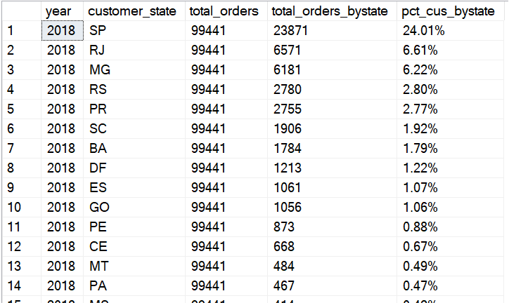

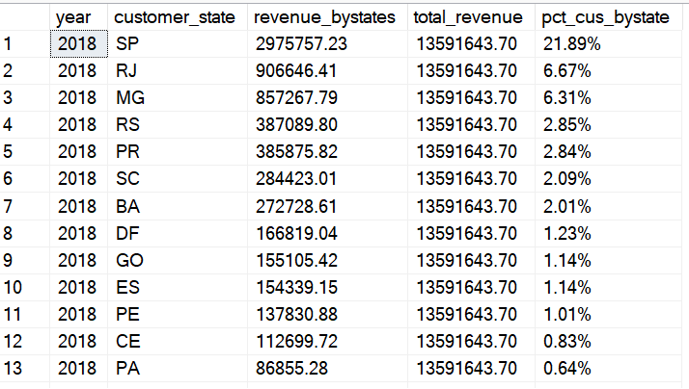

II.3 - SQL

Total Delivered Order Qty/ Revenue in 2018 by Product Category (70 rows)

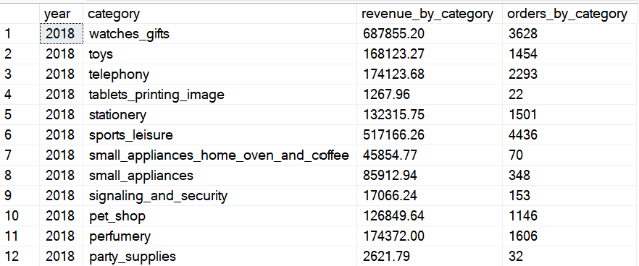

II.4 - QSL

The growth of payment type from 2016 to 2018

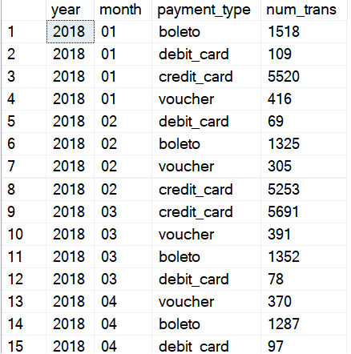

II.5 - SQL

Count transactions by payment installments (24 rows)

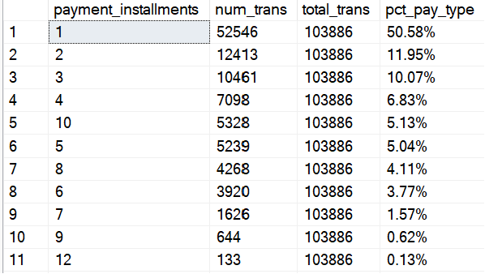

II.6 - SQL

Query the number of orders by Review Scores

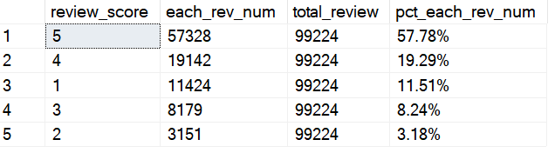

**DASHBOARD 3**

1 - SQL

Top 5 states have the highest 5-review score orders qty

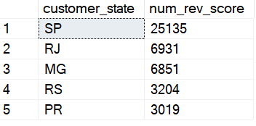

2 - SQL

Top 5 states have the highest 1-review score orders qty

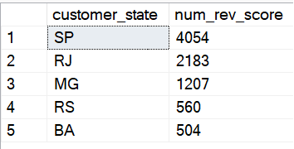

3 - SQL

Top 5 states have the highest avg freight value

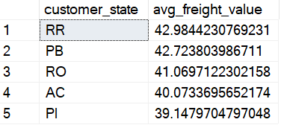

4 - SQL

Top 5 states have the lowest avg freight value

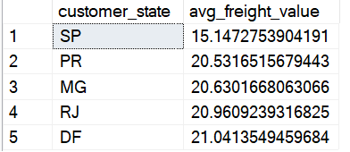

5 - SQL

Top 5 states have the highest avg time of delivery

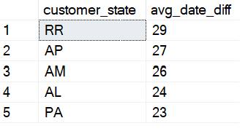

6 - SQL

Top 5 states have the lowest avg time of delivery

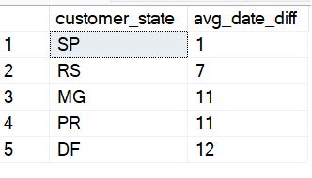

7 - SQL

Top 5 states have the order qty that were delivered faster than time estimation

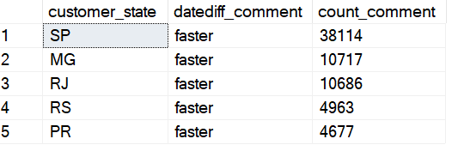

8 – SQL

Top 5 states have the order qty that were delivered slower than time estimation

